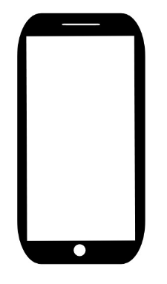

**Ultrasonic HC-SR04 Sensor**

**Water Level Measurement**

**Data Analysis for Prediction**

**Model**

**All Alert**

**Live Status**

**Water level Increase Rate**

**Node MCU**

**ESP 8266**

**Raindrops Detection**

**DTH 11**

**Temperature**

**Humidity**